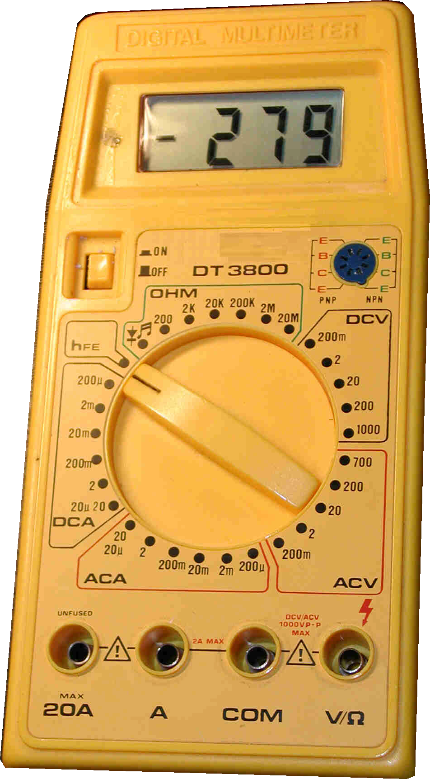
Digital Multimeter DT 3800

